Program 1
// Program to swap two numbers using pointers

#include <stdio.h>
void swap(int *num1, int *num2)
{
int temp = *num1;
*num1 = *num2;
*num2 = temp;
}

int main()
{
int num1, num2;
printf("Enter two numbers:\n");
scanf("%d %d", &num1, &num2);
swap(&num1, &num2);
printf("\nAfter swapping,\nNum1: %d\nNum2: %d\n\n", num1, num2);
}

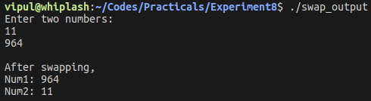
Program 2
// Program to calculate area and perimeter of a circle via call by reference

#include <stdio.h>
void cal(float *r, float *area, float *peri)
{
*area = 3.14 * (*r) * (*r);
*peri = 2 * 3.14 * (*r);
}

int main()
{
float r, area, peri;
printf("Enter radius of circle:\n");
scanf("%f", &r);
cal(&r, &area, &peri);
printf("\nArea of circle: %f\nPerimeter of circle: %f\n\n", area, peri);
}

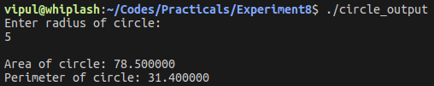
Program 3
// Program to find largest among 3 numbers via call by reference

#include <stdio.h>
void largest(int *a, int *b, int *c, int *max)
{
if (*a > *b && *a > *c)
*max = *a;
else if (*b > *a && *b > *c)
*max = *b;
else
*max = *c;
}

int main()
{
int a, b, c, max;
printf("Enter 3 numbers:\n");
scanf("%d %d %d", &a, &b, &c);
largest(&a, &b, &c, &max);
printf("\nLargest number is: %d\n\n", max);
}

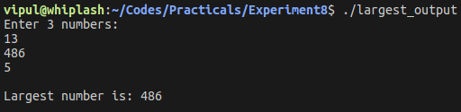
Program 4
// Program to calculate sum of digits of a number via call by reference

#include <stdio.h>
void cal(int *num, int *sum)
{
while (*num > 0)
{
*sum += *num % 10;
*num /= 10;
}
}

int main()
{
int num, sum = 0;
printf("Enter a number:\n");
scanf("%d", &num);
cal(&num, &sum);
printf("\nThe sum of digits = %d\n\n", sum);
}

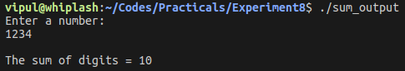
Program 5
// Program to reverse a number via call by reference

#include <stdio.h>
void cal(int *num, int *rev)
{
while (*num > 0)
{
*rev = (*rev) * 10 + *num % 10;
*num /= 10;
}
}

int main()
{
int num, rev = 0;
printf("Enter a number:\n");
scanf("%d", &num);
cal(&num, &rev);
printf("\nThe reversed number = %d\n\n", rev);
}

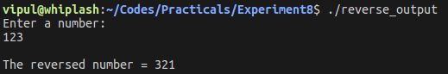
Program 6
// Program to find factorial of a number via call by reference

#include <stdio.h>
void cal(int *num, int *fact)
{
for (int i = 1; i <= *num; i++)
*fact *= i;
}

int main()
{
int num, fact = 1;
printf("Enter a number:\n");
scanf("%d", &num);
int temp=num;
cal(&num, &fact);
printf("\n%d! = %d\n\n",temp, fact);
}

